Armstrong’s Axioms in Functional Dependency in DBMS

The term Armstrong axioms refer to the sound and complete set of inference rules or axioms, introduced by William W. Armstrong, that is used to test the logical implication of **functional dependencies**. If F is a set of functional dependencies then the closure of F, denoted as , is the set of all functional dependencies logically implied by F. Armstrong’s Axioms are a set of rules, that when applied repeatedly, generates a closure of functional dependencies.

F+

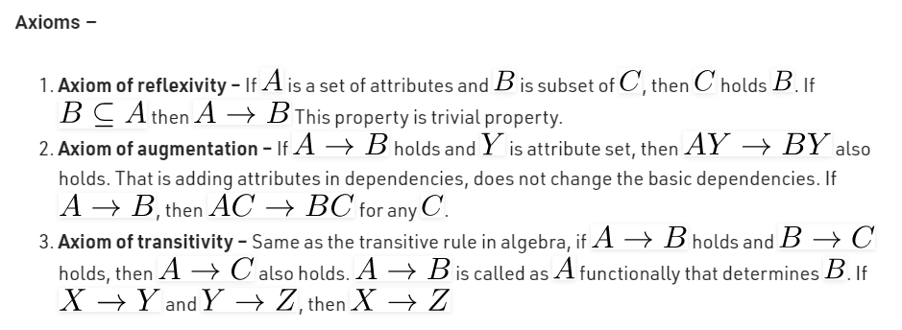

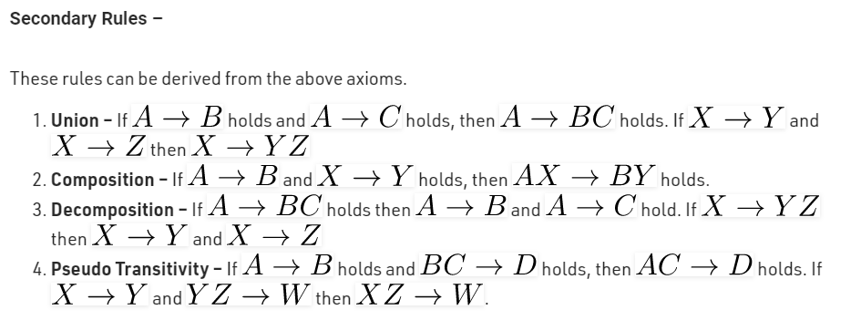.

**Why armstrong axioms refer to the Sound and Complete?**

By sound, we mean that given a set of functional dependencies F specified on a relation schema R, any dependency that we can infer from F by using the primry rules of amrmstrong axioms holds in every relation state r of R that satisfies the dependencies in F.  
By complete, we mean that using primary rules of amrstrong axioms repeatedly to infer dependencies until no more dependencies can be inferred results in the complete set of all possible dependencies that can be inferred from F.